**Mental Health Wellbeing and Recovery Services**

Referral Form

**Provider Details for Referral Forms:-**

**Leicester City, Oadby, Wigston & Blaby**

[**Richmond.fellowshiplifelinks@nhs.net**](mailto:Richmond.fellowshiplifelinks@nhs.net)**. Free Phone 0800 0234575 (SPOA)**

**1st Floor 60 Charles Street, Leicester. LF1 1FB**

**Charnwood, North West Leicestershire, Hinckley & Melton**

[**leicestershire.andrutland.mhm@nhs.net**](mailto:leicestershire.andrutland.mhm@nhs.net) **Free phone 0300 3230 189 Single Point of Access: Swithland Suite The Crescent, 27 King Street, Leicester LE1 6RX**

**Harborough**

[Harborough.mindmatters@nhs.net](mailto:Harborough.mindmatters@nhs.net) **01858 411383**

**1st Floor Torch House, Torch Way, Market Harborough, Leicestershire LE16 9HL**

|  |  |
| --- | --- |
| **Full Name** |  |
| **Date of Birth** |  |
| **Current address** |  |
| **Contact Number** |  |
| **Email Address** |  |
| **NHS Number** |  |
| **GP Name address & Contact number** |  |
| **Ethnicity** |  |
| **Gender Preference** |  |

|  |
| --- |
| **If you are referring someone into the service please print your details and confirm that you have gained consent from the individual being referred.**  **Name…………………………………………………….. Date……………………………….**  **Email……………………………………………………… Tel………………………………...**  **Job Title…………………………………………………. Consent Gained Yes/No** |

|  |
| --- |
| **Reasons for referral** |
|  |

|  |
| --- |
| **Any Specific Support e.g. interpreter** |
|  |

|  |  |  |
| --- | --- | --- |
| **Known Risks (detail any evidence of risk in the areas listed - Yes or No or not known)** | | |
| **Dangerousness / risk to others** |  | **Details:** |
| **Risk of self-harm / Self-neglect** |  |
| **Known to Social Services** |  |
| **Suicidal Thoughts / Attempts** |  |
| **Substance Misuse** |  |
| **Physical / Verbal Aggression** |  |  |
| **Other** |  |  |
| **Signature of referrer: Date:** | | |

|  |
| --- |
| **By signing this form I give consent to the organisation receiving personal information from my referral agent and or any other agencies involved in my current or previous care/support. I understand that they will handle all information in line with Data Protection Legislation and their own Confidentiality and Information Governance Protocols.**  **Signature……………………………………………. Date………………………………..** |

|  |  |
| --- | --- |
| **Names of any other professionals or organisations involved** | |
| **Name** | **Contact Details** |
|  |  |
|  |  |
|  |  |
|  |  |

**Internal Use only:**

|  |  |
| --- | --- |
| **Date received** |  |
| **Date Actioned** |  |
| **Outcome : Telephone support, 1-1 support ,Signposting** |  |
| **Assigned to** |  |
| **Signed** |  |
| **Date** |  |

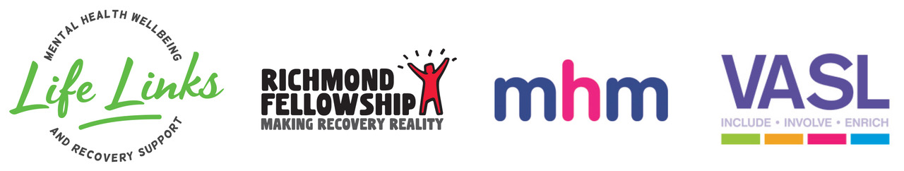

**Mental Health Wellbeing and Recovery Services Funded by:**

