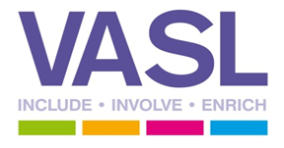
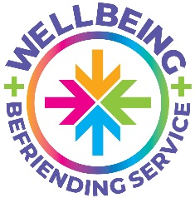
VASL currently deliver two projects supporting adults with mental health issues within the Harborough district – My Mind Matters and Wellbeing Befriending Service. We are currently in the process of gathering information to help VASL identify need and secure further funding for mental health support.
We would like to hear your views on community mental health and wellbeing services that are provided in the district. We have put together a short questionnaire and appreciate you completing the form.
Please return the questionnaire to: wellbeing@vasl.org.uk by the 21st February 2022.

Q1. What support do you or the organisation you are part of provide for adults living in the Harborough district with mental health issues?

Q2. What services do you work in close partnership with, and where are you most likely to signpost to? (Both nationally and locally)

Q3. In your experiences what are the key barriers that prevent an individual from accessing support?
Please tick any boxes that are relevant
Covid 19 |  | Stigma
Fear |  | Transport
Anxiety |  | Money
Feeling disconnected |  | Physical health issues
Digital barriers |  | Lacking confidence
Mental health issues |  | Feeling isolated
Long waiting lists |  | Not feeling welcome, respected or heard

Anything else that can get in the way of people accessing the support they need?

Q4. We recognise that everyone’s recovery journey is personal. From your experiences what interventions and services have made a positive difference in terms of improving overall wellbeing?
(E.g. connecting with nature, space to share experiences, informal gatherings, volunteering, befriending, goal setting, talking therapies).

Going forward what services would you like to see in the Harborough District to support adults to improve their mental health and overall wellbeing?

Thank you for taking the time to complete this questionnaire; your feedback is important to us. All feedback received will be reviewed and considered in the development of our proposals. Any sharing of feedback we receive will remain anonymous and we will keep your personal details confidential.

